H.T No
Regulations:
A14

Sreenidhi Institute of Science and Technology
(An Autonomous Institution)
Code No: 4C303 Date: 28-Oct-2020 (FN)

B.Tech II-Year I-Semester External Examination, October - 2020 (Supplementary)
PROBABILITY THEORY AND STOCHASTIC PROCESS (ECE)

Time: 2 Hours Max.Marks:70

Note: a) No additional answer sheets will be provided.
b) All sub-parts of a question must be answered at one place only, otherwise it will not be valued.
c) Missing data can be assumed suitably.

ANSWER ANY 5 OUT OF 8 QUESTIONS. EACH QUESTION CARRIES 14 MARKS.

1. | a) | State and prove total probability theorem. | [7M]
 | b) | A missile can be accidentally launched if two relays A and B both have failed. The probabilities of A and B failing are known to be 0.01 and 0.03 respectively. It is also known that B is more likely to fail (probability 0.06) if A has failed.  (i) What is the probability of an accidental missile launch?  (ii) What is the probability that A will fail if B has failed. | [7M]
2. | a) | A random variable X is Gaussian with 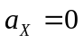 and 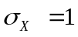. What is the probability that |X| > 2? | [7M]
 | b) | Find the density function whose characteristic function is exp(-|t|). | [7M]
3. | a) | Define joint probability density function. List out its properties. | [7M]
 | b) | 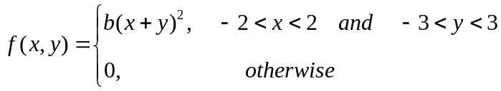  (i) Find the constant b such that this is a valid joint density function.  (ii) Determine the marginal density functions 𝑓(𝑥) 𝑎𝑛𝑑 𝑓(𝑦) | [7M]
4. | a) | With neat sketches explain the classification of random process based on time t and amplitude of random variable X. | [7M]
 | b) | Consider a random process X(t)=A Cost, where is a constant and A is a random variable uniformly distributed over (0,1). Find the auto correlation and auto covariance of X(t). | [7M]
5. | a) | Suppose that the input to a differentiator is the WSS random process. Determine  the power spectral density of output. | [7M]
 | b) | Derive the relationship between autocorrelation of output random process of an LTI system when the input is a WSS process. | [7M]
6. | a) | List out the properties of band-limited random process. | [7M]
 | b) | Find the mean square value of the output response for a system having h(t)=e^{-t} u(t) and input of white noise N_{o}/2. | [7M]
7. | a) | A random variable X has the following probability function: Values of X given by  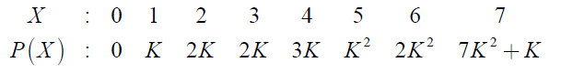  Find (i) K , (ii) Evaluate 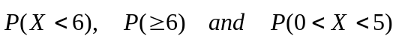. | [7M]
 | b) | Distinguish between discrete, continuous and mixed random variables with suitable examples. | [7M]
8. | a) | Given a random process X(t)=Ysinωt, where Y is a random variable uniformly distributed in the range (-1, 1). Is the process ergodic. | [7M]
 | b) | Write notes on the following terms:  i) Thermal noise ii) Narrowband noise. | [7M]

-- 00 -- 00 –

